***Time limitation quiz 1.***



Name:

FCU ID:

Team number:

**Background:**

A firefighter, also known as a fireman, is a highly skilled man or woman who works to combat and extinguish fires. They also take steps to prevent fires, act as emergency medical technicians (EMT) and investigate the causes of fires. A firefighter is almost always the first official "on the scene" of fires, car accidents, or other emergencies, which is why they are also sometimes called "first responders."

As a firefighter, daily duties are different, but could include:

* inspecting and maintaining equipment
* carrying out practice drills and taking part in training
* rescuing people and animals from burning buildings and accident sites
* controlling and putting out fires
* dealing with bomb alerts and floods
* managing chemical or hazardous substance spills
* giving presentations to schools and community groups
* inspecting buildings to make sure they meet fire safety regulations

A fireman frequently puts himself at risk, not only from fire but also from exposure to many other job-related hazards.

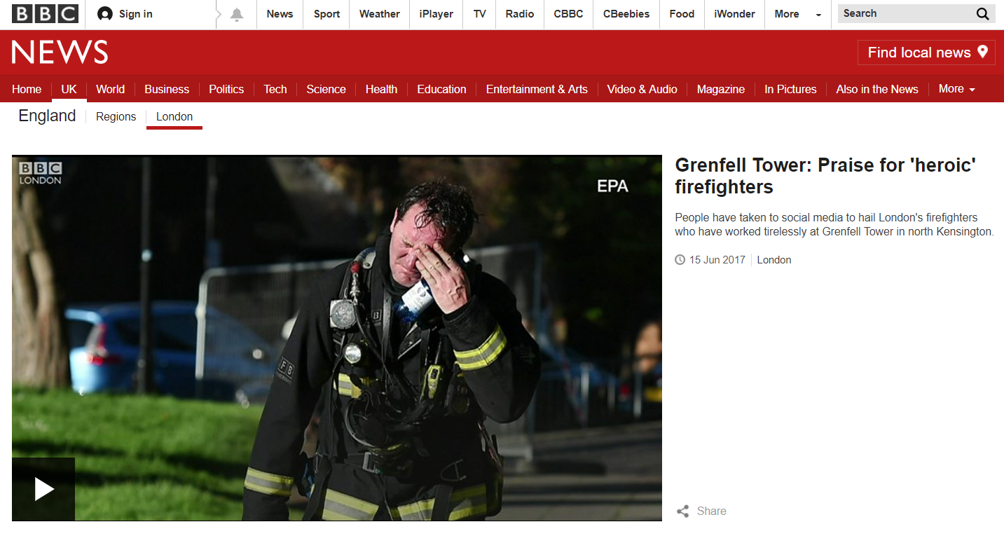

**Project:**

In the government budget of this year, it is planning to provide a funding for firefighting equipment upgrading. The main purpose of this upgrading is to reduce the death in line of duty for firefighters. Try to analyze the data “Time limitation quiz 1. Firefighter_database.xlsx” and write an evidence-based report for the government with suggestion of three firefighting equipment or facilities that required to be upgraded preferentially.

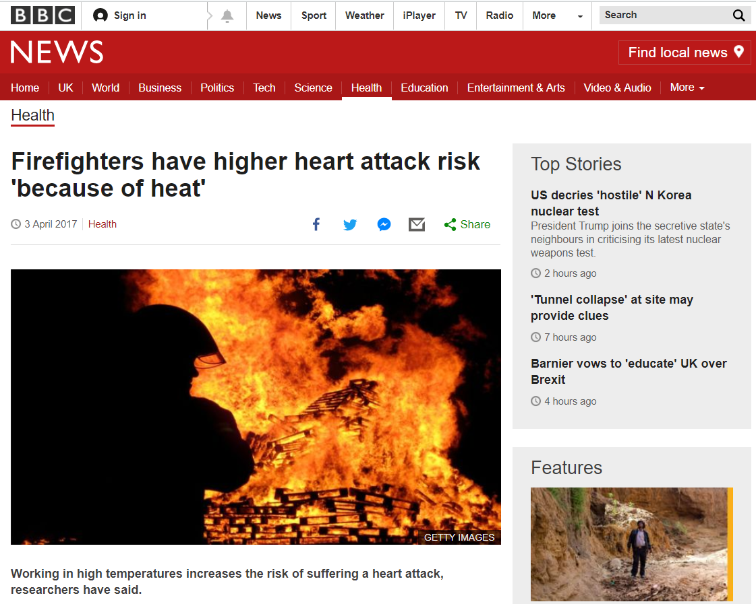

|  |
| --- |
| **Learning objectives:**  *Review what you learn before:*   * **ET03:** Justify graphical representation based on data characteristics. * **ET04:** Prepare chart or table for technical presentation with proper formatting (headers, units, meaningful decimal points, appropriately scaled axes, appropriately sized marker and axis labels). * **ET05:** Create a histogram with meaningful number of bins and width/sizes. * **DA01:** Describe, with calculations, the central tendency of data using descriptive statistics (mean, median, and mode). * **DA02:** Describe, with calculations, variability of data using statistical methods (standard deviation, variance). * **DA03:** Make accurate comparisons across groups with explicit reference to data. * **DA04:** Given independent and dependent variables, interpret or predict the performance of a solution. * **DA05:** Given two variables, describe the relationship and/or calculate the strength of the correlation between these variables. * **DA06:** Interpret the distribution of data in a graph * **PC01:** Use professional communication (written, visual, and oral), free of grammatical or spelling mistakes and in a formal tone, appropriate for engineering school and workplace. * **PC02:** Make clear and complete arguments or statements by fully addressing all parts of the assignment. * **SQ01:** Use accurate, scientific, mathematical, and/or technical concepts, units, and/or data in solutions. * **SQ02:** Justify design solution based on how well it meets criteria and constraints. * **UC01:** Demonstrate an understanding of conservation principles (mass, energy, momentum, and/or charge) in a boundary system. * **UC02:** Describe systems or processes using schematic diagrams with inputs, outputs, and accumulations. * **UC03:** Define systems or processes with mathematical models with simulation results. * **UC04:** Calculate efficiency of a system, product, or process as it relates to cost, energy, or other engineering factors. * **PA01:** Identify strengths and limitations in one’s problem solving/design approach.   ***You will be graded on completion of the above objectives!*** |

**Answer columns:**

|  |
| --- |
| **Analysis report** |
|  |

**Executive Summary**

Your executive summary should address the topics listed below. Consider using the headings listed in the table below in your Executive Summary. Use the data generated in your analyses to justify your choices.

|  |  |  |
| --- | --- | --- |
| Content | Description | |
| Problem Statement |  | |
| Suggestion of three equipment or facilities |  | |
| Evidence | Nature of Death |  |
| Cause of Death |  |
| Duty |  |
| Activity |  |
| Property Type |  |
| Conclusion |  | |

**Individual contributions**

Individually, each team member should describe his/her contributions to these activities.

|  |  |
| --- | --- |
| **Team member name** | **Team members’ contribution to the team activities above** |
|  |  |
|  |  |
|  |  |
|  |  |